Student Sentiment Analysis

**By:**

Arun J.

Shreyas Nagesh

Pradhumna Guruprasad

**Date:** 8/11/2020

SLAC 2020 Hackathon

# The story so far…

Due to this pandemic all of us have been forced to shift to an online classroom environment. This is a tectonic shift between the way teachers have to teach now and the way they have been teaching for so many years in the classroom. In a live classroom, teachers can figure out if the lecture is well received or not, whether their method of delivery is good or bad by looking at the students’ body language. But in a virtual classroom this is not possible. All the students have just become icons in the screen. Due to this, teachers receive inadequate feedback which seriously hampers their ability to teach effectively. Our solution aims to fix this feedback gap and also provide the management and staff with statistics on the quantity and quality of the online classes which is very helpful for them to see how well the classes are going.

# Our solution

Based on the attendance files from MS Teams the teacher uploads to our webpage, we take the data and present it in an easy to read tabular and graphical form with the attendance of the students only being considered if they have stayed for 80% of the class duration or longer. This makes the job of the teacher easier since they do not have to manually check if anyone just joined for 2 minutes just for the sake of attendance. We also present the teacher with graphs showing how many people completely attend their lectures and how many just login for attendance. These graphs pictorially show the teacher the quality of the class and the number of people interested to listen to their lectures. We also plot out a trend graph showing this over the course of many days which gives them this picture over a long term.

If needed, a teacher can also search for a particular student to see his track record of attendance in a tabular form.

# How it works : UX and UI

First a teacher will need to make an account on our website by registering. He/she will then need to login with their account to view their dashboard. Here they can upload the attendance csv file from MS Teams. Once they do this, they will be able to view a table with the attendance of the students on each day. Along with this they will be able to filter out the attendance of a single student if they wish to see so. Graphs showing the trend of number of students attending their class over a period of many days is also displayed beside the table. This gives them a good understanding about how the perception of students regarding the course is over a longer period of time. This feedback would benefit the teacher immensely and he/she can alter their teaching style or methodology to try to attract the attention of more students.

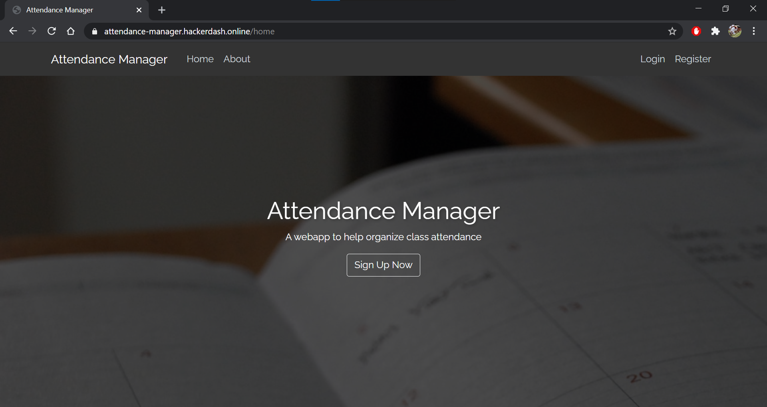

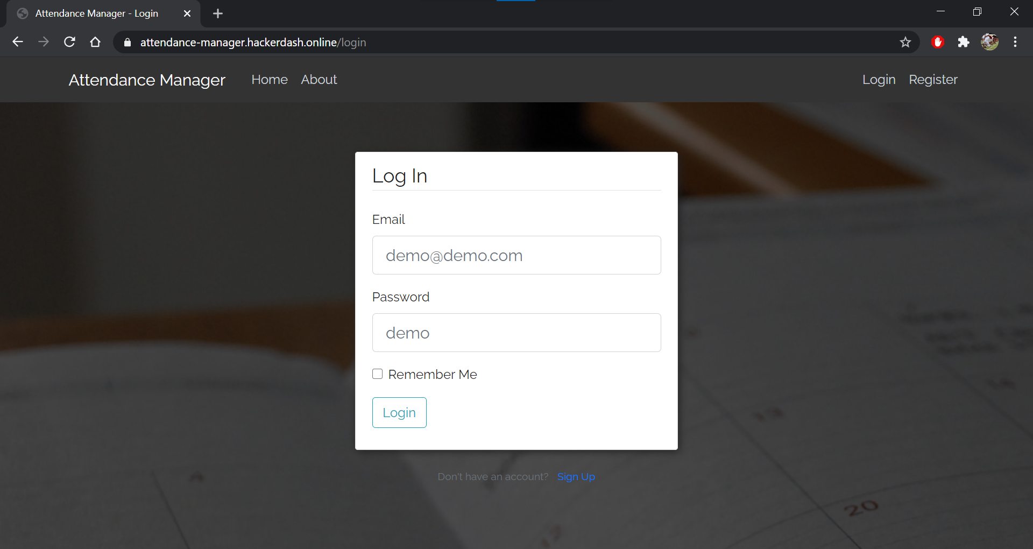

# Conclusion & Future scope

Our project aims to solve one of the biggest problems in an online mode of education. We try to help the teachers understand their audience base better in this online mode, which helps them to deliver better lectures and tailor content more suited for the students’ needs. We also hope to add a view for the management also, so that they can see which teacher is able to do better and which courses the students seem to be most well received and so on.

This is the need of the hour now and we have to adapt better to this online mode of teaching and learning. With these additions, we now have much more data to visualise and look at, more than we could have ever obtained in the offline mode of education. We can now see how each student, teacher, class, course, branch is doing with this data. This analysis was not possible in the offline mode of education. This data from each teacher can be sent to the cloud which can use machine learning and AI to process it along with the grades of each student. This can reveal much more information about each class and this data would be extremely valuable for the management.

With this we would be able to be much more productive and make the most out of the online classes conducted in this pandemic and beyond.

